xpedx.com Next generation
Order Management in Call Center Design Document

Authors: Sterling Commerce

Date Created: 04/12/10
Last Updated: 07/17/10
File Name: C:\Documents and Settings\bfurman\My Documents\Temp\Methodology v1.1\Project Management\TEMPLATE - DOCUMENT - Use Case Definition.doc0000.doc

Approval Signatures (Mandatory)

Title | Name | Signature | Date | Comments / Issues / Concerns
xpedx Owner(s) | Steve Bugher
xpedx Owner(s) | Cheryl Tullis
Sterling Commerce Owner(s) | Guy Read

Note: The sign off indicates approval of all sections of the document.

Document Revision History

This chart tracks the changes introduced by the revisions to the document as the project progresses through the stages of the System Development Life Cycle (SDLC).

Version | Date | Description (Changes Made) | Author(s)
0.1 | 03/01/2010 | Initial Draft | Sterling
1.0 | 03/04/2010 | Ready to Deliver | Sterling
2.0 | 06/15/2010 | Incorporated review comments from xpedx | Sterling
3.0 | 07/02/2010 | Incorporated review comments from xpedx | Sterling
4.0 | 07/02/2010 | Minor updates per xpedx | Sterling
5.0 | 07/12/2010 | Included updated set of statuses | Sterling
6.0 | 07/16/2010 | Included status for Customer Hold | Sterling

Related or Reference Documents

Document Name | Description | Owner | Location
SCI_Xpedx Solution Definition Document v1.5 | Solution Definition document | Sterling Commerce
xpedx Order Business Rules Detail Design v1.0.doc | Order Business Rules document | Sterling Commerce
Xpedx Order Place Detailed Design V1.2.docx | Order Place Interface Design document | Sterling Commerce
xpedx Order Hold in Call Center Detailed Design v8.0.doc | Order Hold Rules in Call Center Design document | Sterling Commerce
xpedx Order Change And Cancel WebChannel Design Doc V1 7.doc | Order Change and Cancel in Web Channel Design document | Sterling Commerce

TABLE OF CONTENTS

1. Introduction 5
1.1 Document Purpose 5
1.2 Document Audience 5
2 Change Order, Cancel Order 6
2.1 Overview 6
2.2 Master System 7
2.3 Process Flow. 7
2.3.1 Update Fulfillment Order 7
2.3.2 Add line to order 8
2.3.3 Cancel line on an order 10
2.3.4 Cancel order 11
2.3.5 Flow Details 12
2.4 Example Screen Shots 15
2.5 Assumptions 18
3 Glossary 18

Introduction

Document Purpose

This document is the governing design document which outlines change / cancel order operations via Sterling Call Center application. Testing, builds, configuration management are not covered in this document.

The document will also serve the purpose of keeping a list of assumptions that were made during design discussions.

Document Audience

This document is intended for management and technical staff working on this project, xpedx IT and Business, Web methods, Legacy(MAX and ACCESS), HP, IW, xpedx/IP Network Team. Sterling will use the document during design and configuration for design consideration.

Change Order, Cancel Order

Overview

The Sterling Call Center application will be used by a CSR to view and update orders which have been placed via various channels eg. EDI gateway, Sterling Web Channel (.com site). A CSR may choose to update an order based on customer request. The status of the order will dictate whether changes can be done on the order.

All updates by the CSR using Sterling Call Center will be done on the Fulfillment Order for orders that have been placed on Legacy, otherwise changes will be made to the Customer order. These updates will flow to the legacy system via the Order Place interface.

Please also refer to Section 2.1.1 Order Change in xpedx Order Change And Cancel WebChannel Design Doc V1 7.doc for the list of changes permitted in the Call Center.

The following changes can be done on the order using the Sterling Call Center.

- Attention Name
- Customer PO #
- Delivery Hold
- Ship Complete
- Will Call
- Ship Date
- Header Comments
- Customer Product Code
- Ordered quantity in Base UOM
- Unit Price in pricing UOM
- Price Override Flag
- Line Description
- Requested Unit Of Measure
- Ordered quantity in Requested Unit Of Measure
- Customer Line Sequence number
- Customer Line PO number
- Customer Line fields
- Customer Line Account number
- Ship From Branch
- Adjustment amount
- Coupon code
- Add line to an order
- Cancel line on an order
- Cancel order

In addition to these operations, all the operations which the CSR needs to execute to resolve a Needs Attention hold on the Order Dashboard can also be done. These operations are detailed in xpedx Order Hold in Call Center Detailed Design v8.0.doc.

Master System
The legacy system is the system of record for all order.

Process Flow.

Update Fulfillment Order

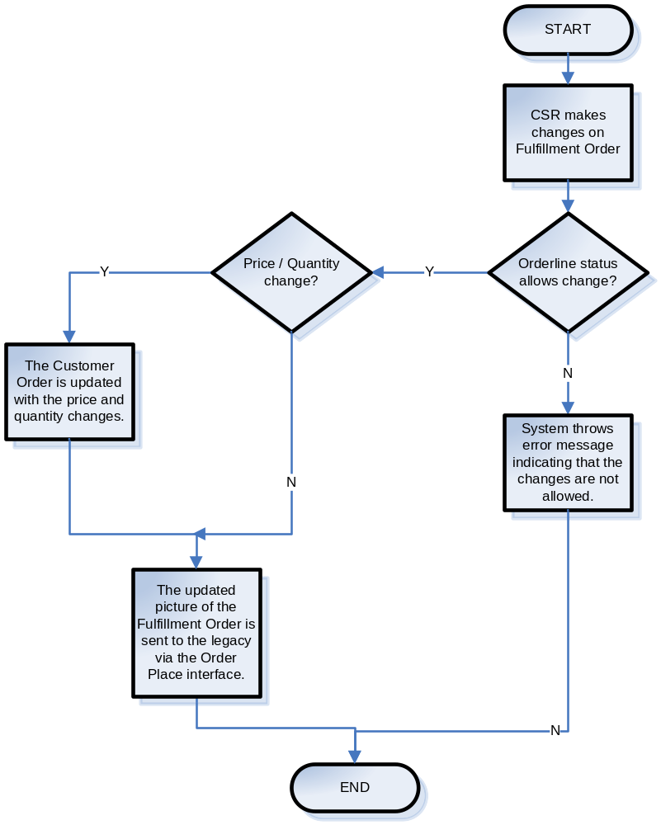

Add line to order

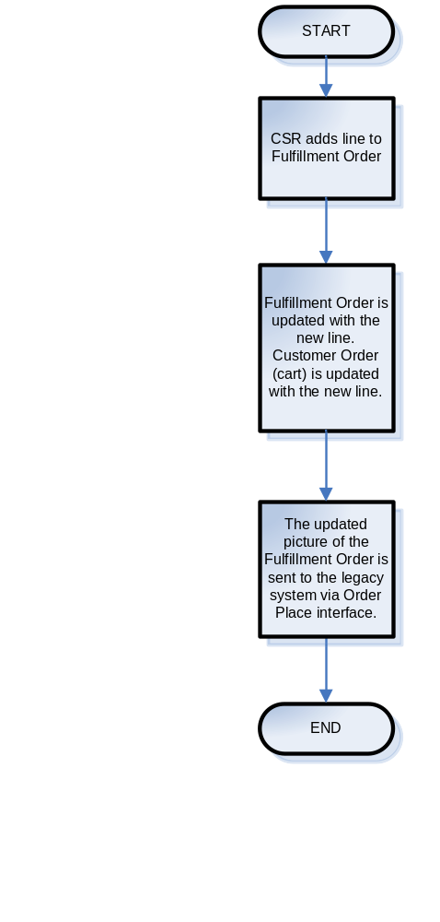

Cancel line on an order

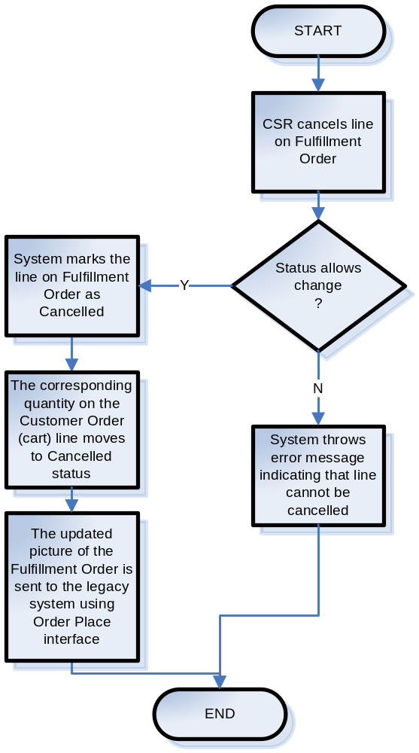

Cancel order

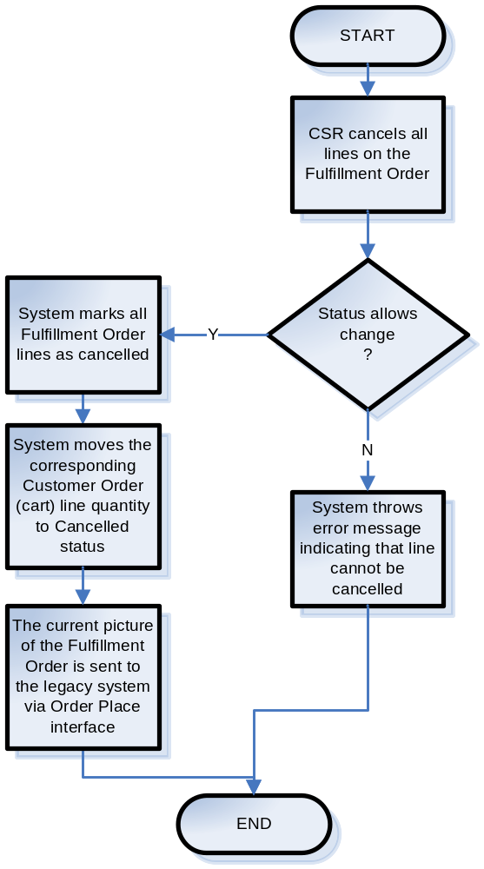

Flow Details

- The order lines and therefore the order are going to move through multiple statuses during its lifecycle. The Sterling system will be configured to allow or disallow certain operations depending on the status the order line is in. This is achieved using Order Modification Rules in the Sterling Applications Manager

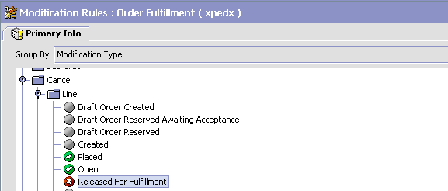

- The order line and hence the order will move through the following statuses –

Status Name | Status Code | Modification Allowed | Cancellation Allowed
Create | 1100 | Y | Y
Placed | 1100.0100 | Y | Y
Web Hold | 1100.0200 | Y | Y
System Hold | 1100.0300 | Y | Y
Customer Hold | 1100.0350 | Y | Y
Open | 1100.0400 | Y | Y
Released | 1100.0500 | N | N
Direct | 1100.0600 | N | N
Shipped | 3700 | N | N
Delivered | 3700.0050 | N | N
Invoiced | 3700.0100 | N | N
Cancelled | 9000
BackOrdered | 1100.0450 | Y for CSR, N for customer user | Y for CSR, N for customer user
Cancelled | 9000 | N | N/A
Return | 1100.0700 | N | N
Credit | 1100.0800 | N | N
Future | 1100.0020 | Y | Y
Quote | 1100.0040 | N | N
Invoice Only | 1100.0900 | N | N
Blanket | 1100.1000 | N | N

- All changes done by the CSR will be done on the Fulfillment Order for orders that have been placed on Legacy, otherwise changes will be made on the Web Order.
- The changes done on the Fulfillment Order will be propagated to Customer Order.
- The updated picture of the Fulfillment Order will propagate to legacy systems via Order Place interface messages.
- Line type is stored in /Order/OrderLines/OrderLine/@LineType attribute on the order document.
- Order type is stored in /Order/@OrderType attribute on the order document.
- If a line is cancelled on the Fulfillment Order, the corresponding line in the Customer Order (cart) moves to Cancalled status. This sends out an interface message to the legacy system via the Order Place interface. This message contains the updated picture of the Fulfillment Order being modified.
- Canceling all the lines on a Fulfillment Order is similar to canceling the Fulfillment Order. The corresponding quantity on the Customer Order (cart) moves to Cancelled status. The updated picture of the Fulfillment Order is sent to the legacy system via Order Place interface.
- If a CSR wishes to split a line to allow it to be fulfilled effectively based on the P&A picture he will execute the following steps.
  - Click on Split Line icon to copy the contents of the line which needs to be split into a template line.
  - Update the quantity and possibly the Ship From Division on the original line.
  - Update the quantity and possibly the Ship From Division on the template line.
  - Click on Update Order to persist the update.
- If the line quantity is increased on the Fulfillment Order, the corresponding increased quantity on the Customer Order (cart) moves to Placed status.
- If the line quantity is decreased on the Fulfillment Order, the corresponding quantity is decreased on the Customer Order (cart).
- If the line type on the Fulfillment Order is changed from STOCK to DIRECT, the line is cancelled on the Fulfillment Order. This sends an interface message to the legacy via the Order Place interface. A new Fulfillment Order is created containing the line with the changed line type. This results in another interface message via the order place interface.

Example Screen Shots

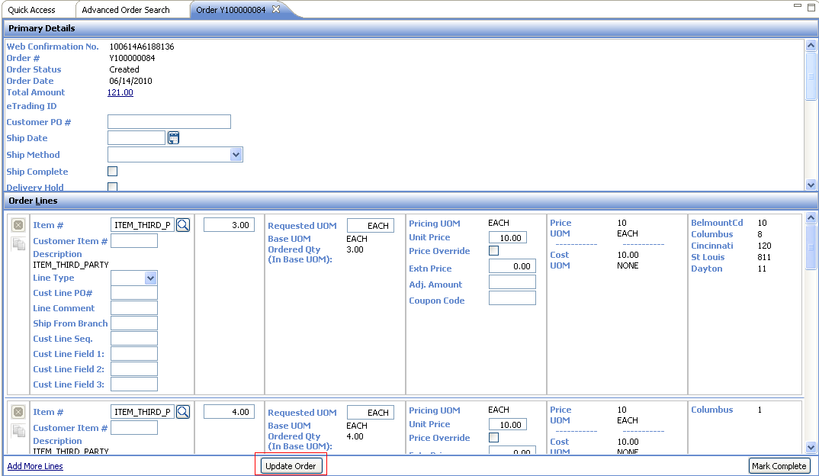

The CSR can click on Update Order after making changes on the Fulfillment Order to persist the changes.

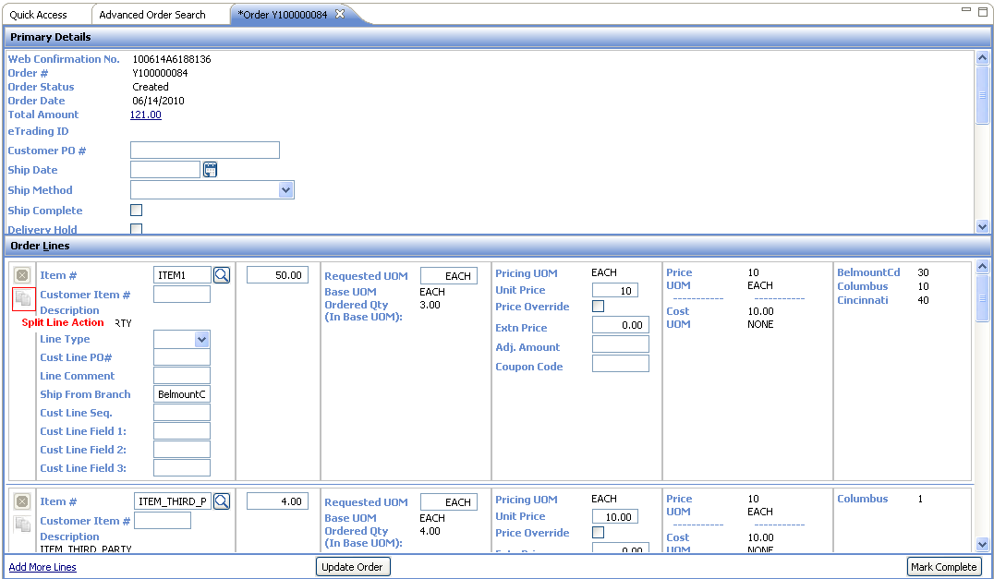

The CSR can use the Split Line icon on the order line to copy the details of the line to a template line.

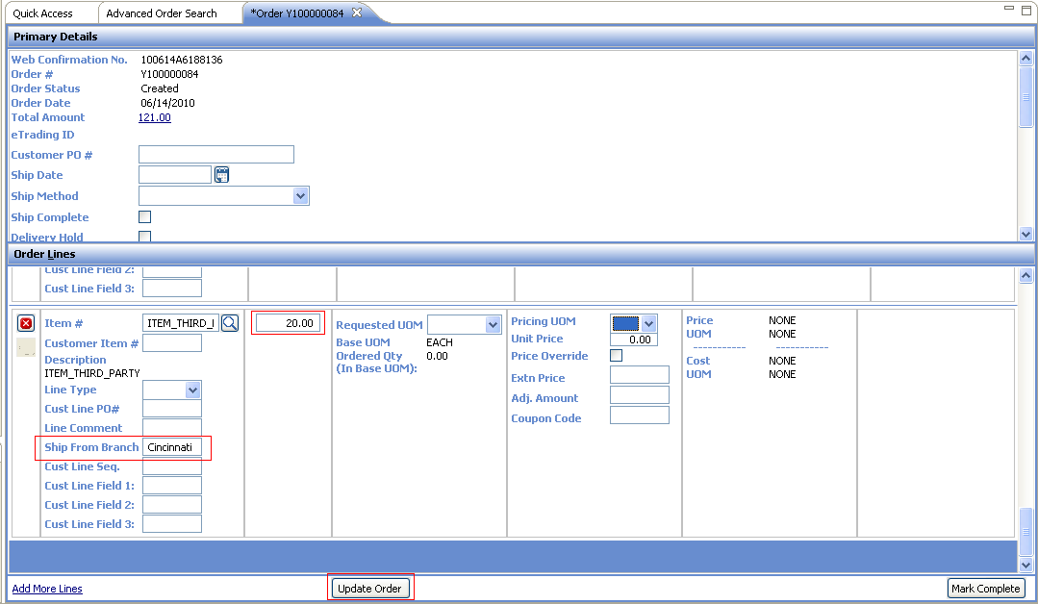

The CSR can then update the required fields on the template line (eg Ship From Branch, Ordered Quantity) and click on Update Order to persist the line.

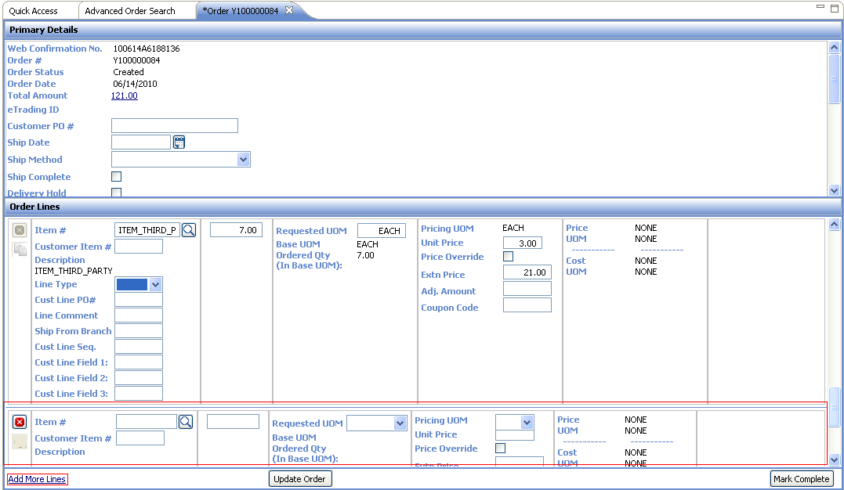
The Add More Lines action can be used to add lines to the Fulfillment Order.

Exception Console

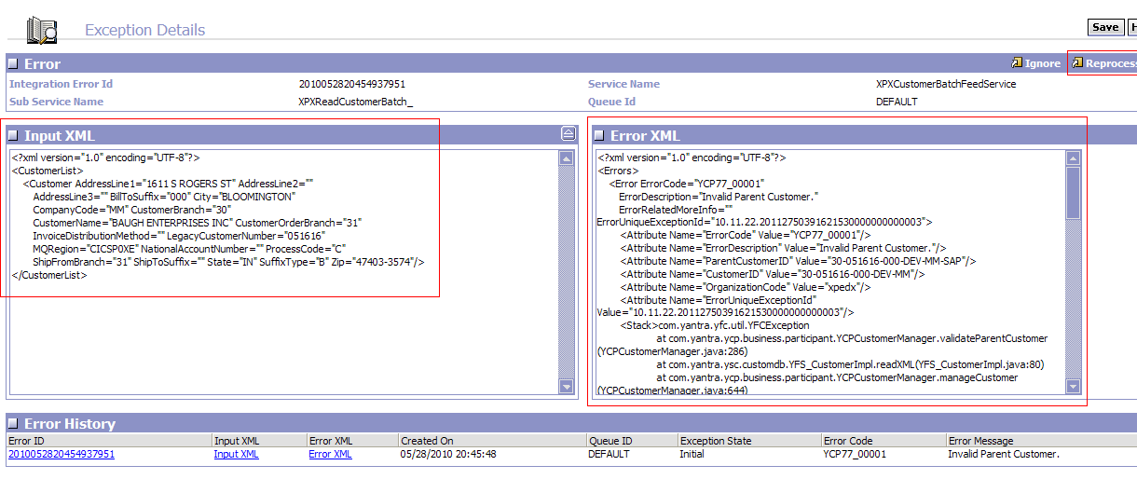

The Exception Console is used query and reprocess integration errors. The Input XML will have the interface XML. The error XML will show the error which occurred while processing the interface XML. The concerned person can update the interface XML based on the error and click on Save. On clicking on Reprocess, the integration server will reprocess the updated interface message.

This console will be used for fix errors related to incorrect eTrading ID and incorrect BuyerID in a B2B Order Place message. The concerned person will update the value of these fields in the Input XML and reprocess the message.

Assumptions
- Only status and price changes on the Fulfillment Order will be propagated to the Customer Order. All other changes will be local to the Fulfillment Order.

Glossary

Term | Definition
Customer Order (Web Confirmation Number level) | Order created via .com site, EDI or COM
Fulfillment Order (Legacy Order level) | This order contains lines which are chained to the Customer Order. This order interfaces with the legacy system.
P&A | Price and Availability interface

